### NOTTINGHAM TRENT UNIVERSITY NOTTINGHAMSHIRE



**“REAL-TIME CLOUD DATA BASED SMART PARKING SYSTEM”**

**MAJOR PROJECT – EMBEEDED SYSTEMS**

Submitted in Partial Fulfilment for the Award of

**MASTERS OF SCIENCE**

in

**ELECTRONICS**

By

**SHAIK SHAHANAZ**

**ID: N0905255**

MODULE LEADER: DR. OMPRAKASH KAIWARTYA

MODULE CODE: ITEC40091

**ABSTRACT**

With the growing population the number of vehicle owners are also increasing, and vehicle became one of the most essential need to the everyone. With the growing vehicle the road capacity of bearing vehicle decreases and leads to traffic congestion but this thing becomes worse when there are no vehicle parking management and if there is allocated place it is unaware to the driver of the vehicles to park and sometimes they park on the roadside which leads to the increase the difficulty for movement of congested traffic. So, there occurs the need of the smart parking management for city.

In this paper a cloud based real time smart parking system based on the IoT for a city is presented which aim to manage the available parking places in terms of providers to represents their parking slots to the driver with location and direction nearby the vehicle which results in reduction in parking slot search time, pre book park slots, reduces the traffic congestion and reduces the increased travel time. In this driver is aware of the location and by the cloud data the driver can dynamically check the availability before reaching and made decision and reduce the supply demand gap between the parking slot providers and drivers.

**TABLE OF CONTENTS**

|  |  |
| --- | --- |
| **COVER PAGE** | **1** |
| **ABSTRACT** | **2** |
| **TABLE OF CONTENTS** | **3** |
| **TABLE OF FIGURES** | **5** |
| **TABLE OF FLOWCHARTS** | **5** |
| **TABLE OF BLOCK DIAGRAMS** | **5** |
| 1. **INTRODUCTION** | **6** |
| * 1. **THE SCOPE OF THE CLOUD BASED SMART PARKING SYSTEM** | **7** |
| * 1. **SOME EXISTING SMART PARKING SYSTEMS** | **7** |
| * 1. **OBJECTIVES** | **8** |
| * 1. **ORGANISATION OF THE REPORT** | **9** |
| 1. **RELATED RESEARCH WORKS** | **10** |
| 1. **METHODOLOGY** | **13** |
| * 1. **PLAN OVERVIEW** | **13** |
| * 1. **BLOCK DIAGRAM** | **13** |
| * + 1. **BLOCK DIAGRAM FOR THE INTERNAL PARKING MANAGEMENT SYSTEM** | **13** |
| * + 1. **COMOPNENTS REQUIRED** | **14** |
| * + 1. **WORKFLOW PROCESS OF PROPOSED PARKING SYSTEM** | **17** |
| * + 1. **THE DESIGN OVERVIEW FOR THE PROTOTYPE OF AN INTERNAL PARKING MANAGEMENT SYSTEM** | **18** |
| * + 1. **THE BLOCK DIAGRAM OF INTEGRATING DIFFERENT PARKING MANGEMENT PROVIDERS TO DRIVER** | **19** |
| * + 1. **WORKFLOW ANALYSIS OF PROJECT’S PROPOSED METHODOLOGY** | **19** |
| * + 1. **THE ACCHITECTURE OVERVIEW DESIGN OF THE PROJECT** | **20** |
| 1. **IMPLEMENTATION OF THE PROJECT** | **21** |
| * 1. **HARDWARE IMPLEMENTATION** | **22** |
| 1. **SOFTWARE IMPLEMENTATION** | **22** |
| * 1. **ALGORITHM FOR THE OUTPUT AT LCD** | **24** |
| **DISPLAY AND SERIAL MONITOR.** |  |
| * 1. **ALGORITHM CODE FOR SHARP IR SENSOR GP2D12** | **24** |
| * 1. **CODE LOGIC FOR SERVO MOTOR** | **24** |
| * 1. **CODE LOGIC FOR Wi Fi MODULE TO CREATE AND ESTABLISH CONNECTION TO THE SERVER AND WEBSITE** | **25** |
| * 1. **The MOBILE APP OR ANDROID APP FOR THE DRIVERS** | **28** |
| 1. **CONCLUSION** | **30** |
| 1. **FUTURE WORK** | **30** |
| 1. **REFERENCE** | **31** |

**TABLE OF FIGURES**

**Figure 1 picture by Sentinel Digital Desk (29 Jan 2020 10:06 AM) which shows irregular management of traffic and parked vehicles at large number on the roadside makes difficult to tackle the situation. 3**

**Figure 2 Proposed architecture of cloud-based parking slot detection 8**

**Figure 3 flow chart of mobile based application 9**

**Figure 4 ARDUINO UNO 11**

**Figure 5 LCD MODULE 16X2 11**

**Figure 6 GP2D12 12**

**Figure 7 SERVO MOTOR 12**

**Figure 8 RED, BLUE, GREEN LED LIGHTS 12**

**Figure 9ESP8266 NodeMCU 13**

**Figure 10 BUZZER 13**

**Figure 11 OVERVIEW ARCHITECTRE DESIGN OF PHASE 1 INTERNAL PARKING MANAGEMENT SYSTEM 15**

**Figure 12 Implemented internal parking management system 18**

**Figure 13 output of IR SENSORS 19**

**Figure 14 wifi code part1 22**

**Figure 15 code part 2 23**

**Figure 16 web code 24**

**Figure 17 login page 25**

**TABLE OF FLOWCHARTS**

**Flowchart 1 WORKFLOW PROCESS 15**

**Flowchart 2 led operation 21**

**TABLE OF BLOCK DIAGRAMS**

**BLOCK DIAGRAM 1 12**

**BLOCK DIAGRAM 2 describing the aporach of project 17**

**BLOCK DIAGRAM 3 overview architectural design of project 18**

**CLOUD BASED SMART PARKING SYSTEM AND DRIVER RECOMMENDATION SYSTEM FOR PARKING USING ARDUINO**

1. **INTRODUCTION**

With the growing populations in the era of mechanical life, the need for vehicles whether it may be two, three or four- wheelers according to one’s comfort and for easy management to meet daily requirement are also growing. Yearly there was the tremendous growth in the buying of new vehicles. With the growth of vehicles there rises the problem like traffic congestion, vehicle parking issues, long waiting time in traffic and in searching a slot for parking as unaware of the location of the parking place, accidents, parking at roadside, extra travel time are there.

|  |  |
| --- | --- |
| Bangalore has worst traffic in the world; Mumbai, Pune ranked in ...  Figure 1 picture by Sentinel Digital Desk (29 Jan 2020 10:06 AM) which shows irregular management of traffic and parked vehicles at large number on the roadside makes difficult to tackle the situation. |  |

As per the article (Desk, 2020) Sentinelassam published this year, presents the latest report by “TomTom traffic Index” which analysis the traffic conditions across the world and states that of the cities of India having the world worst traffic condition, in which Bangalore tops the list despite of continuous efforts taken by the traffic management of the city. The clogging of road due to roadside parking (Jul 20, 2019 and Ist, n.d.) as the driver of the vehicle is unaware of the location and availability of the nearest slot for parking makes driver to park at the roadside and bears fine for parking at non parking zones. So, there lies the supply demand gap between the users and parking zones providers and if this gap is fulfilled then this will be benefited to everyone and reduces the above-mentioned problems.

The key challenging task for the driver to detect the nearest parking slot. As per the survey report done for heavily traffic congested cities the among various cities of the world, it takes more than 50% of the time to locate palace to park which end up in wastage of time and fuel. This problem can be resolved by pre- reserving or knowing the availability of the nearest parking slots with respect to the driver. So, there occurs the need for the driver’s parking recommendation system as per the vehicle. This proposed parking system is not restricted to city or the places with bottleneck traffic conditions but if it is implemented to all over the country as like the google maps to avoid future traffic and parking issues and comfort to driver from the hectic traffic, safety of vehicle, proper utilization of time and money.

* 1. **THE SCOPE OF THE CLOUD BASED SMART PARKING SYSTEM**

In this smart parking system, the driver can pre-book the parking slot and can know the availability of the nearest parking slot with price and direction. The implementation of high price at the congested area due to low availability of the parking slots and due to traffic. The cloud-based data management is used for the faster and secured data transmission and the load management among the servers. It provides the reliable communication between the user and parking management system with the real time data for accurate knowledge of the information to driver with all updates by continuously monitoring the database of local server with the central repository. This paper represents the model scheme method for the pre detection and smart parking management system especially in urban areas or the areas where there a need for the parking and traffic related issues.

This project report is on the implementing the a well organized parking system where a driver can know the location of the allocated parking area with all the details such as free or paid parking with showing the facilities which were a driver can be use that provided by the management of the parking area. this paper proposes a concept of driver recommendation system for parking their vehicle by the easy slot detection inside a parking area and interfacing the driver and different parking management system through web and android based application that can be easily accessible through internet of things (IoT) by using wireless sensor networks (WSN).

* 1. **SOME EXISTING SMART PARKING SYSTEMS**

There are many countries like India, Dubai, UK, USA, Germany, Japan, China etc. are working on the development of smart parking system as in the part of smart cities to meet the need of the people and reduce the management issues related to traffic, parking, accident and many other related problems which is explained in this report can be solved by fully developed smart parking

system. Here are some of the existing parking system with its detail description of features and the extent of approach which is relevant to this report work.

In India a group of people Rasika Pansare, Chirag Jain, Rahul Gupta have successfully implemented a IoT based mobile- based parking management system (Tyagi, 2018)through the app named as Get My Parking in city Delhi where driver gets the real time updates parking vacancies in the city with the location and type of payment by providing the required communication between the management of parking and driver of the vehicle and they had digitized over 300 parking slots. This is further need to develop by add booking of parking slot and instantaneous change in price in certain over- crowded and traffic congested areas. In this implemented technology they further need to develop the solution related to the manpower management in the parking areas as the by introducing the automated identification of the slot in parking area as well as in the application through which the driver is connected through internet.

RTA Dubai launches ‌ (Verdict Traffic, 2017) “Smart Parking Project” at Al -Rigga and at the WTC by installing sensors which detects the vehicle and updates the information so that the users can provided with real time information of the vacancies of the parking slots at different areas with the duration of the parking and parked vehicles. This is confined to very small area and can be upgraded by using further smart sensors with the applied one such as smart cameras, distance tracking sensors, and also the updating the facility of different vehicle other than cars.

The report deals with the build and development of a parking management system for assisting the driver to park their vehicles smartly without much effort majorly focusing of the concept of assisting the remote driver about the location of the parking area with the availability of slots, type of parked spaces like free or paid parking, pre- booking facility and directions to the nearby or selected location of the parking area.

* 1. **OBJECTIVES**

The objectives which are considered for the development of this project work report are illustrated below.

* Locating the parking spots or parking areas near the driver.
* Recommendation system for the driver to park the vehicle based on the price, distance, directions, price.
* Developing a smart Internal parking system which can –

Displays the availability of slots at screen before entering the area.

Automated opening of the gates at the entry by vehicle detection by scanning the number plate if the empty parking slots are available and distance detecting sensors.

Inside the parking area easy detection of the slot by the colored led lights provided at each slot.

Buzzer and colored light indication as alarm to driver to avoid collision to the wall or entering pre- booked or already parked slots to reduce the human errors.

* + - * Controlled operations of the sensors in the internal management system by using a controlled board like Arduino.
      * Connecting the controller board for further operation and monitoring purpose of the system to the local sever by using WIFI module to the Arduino Uno.
      * Establishment of the connection between all the parking areas management local servers to central cloud repository of central cloud server with the approaches of IoT wireless sensor networks WSN which can be managed by web-based applications.
      * Developing and implementing a cloud -based server as a medium between the user parking area with vast database as the data can be managed, maintained and provides the reliable communication as the driver location is undetermined.
  1. **ORGANISATION OF THE REPORT**

This project report “CLOUD BASED SMART PARKING SYSTEM AND DRIVER RECOMMENDATION SYSTEM FOR PARKING USING ARDUINO” is divided into 8 chapters. Each chapter explain the development phases of the product development. **Chapter- 1** states the need for the development of this system by evaluation of the present state of the related issues and development approach by describing aim and objectives. **Chapter -2** in this report work deals with the related work that has been carried out and different proposed concepts that has been suggested and implemented in developing this system. The methodology of the project is explained in the **chapter-3** where the project plan and the integration of the different system in terms of the block diagram is presentenced with reflecting the different phases of the development required for the development of the proposed prototype with cleared description of the workflow process and smart design architecture is used to demonstrate the working mechanisms. The hardware and software implementation of the project at various stages are discussed here in the **chapter -4**. The output and its analysis is dealt with the **chapter -5** and in **chapter -6** the conclusion of the project is done and at last all the related references which were considered in writing this report.

1. **RELATED RESEARCH WORKS**

Many previous research works has been developed for smart parking systems based on using various approaches of IoT technologies such radio frequency identification RFID, ultra-high frequency (UHF), wireless sensor network WSN which provides the better data transmission and object detection and tracking but these systems are confined to smaller area as of its range. Few sensors which are used to detect and manage the automatic operations through the controller board such as light detecting and motion detecting sensor, proximity sensors, IR sensors, ultrasonic sensors in the individual parking system. These systems are confined to the internal management of the parking slots but when the driver can’t able to locate the parking area, but driver can know the availability of the parking slot before entry into the area by the LCD. Some of the following previous works which has been taken into consideration for this project work are briefly described.

* **A Case Study: Growing Parking Issues and Effective Parking Management Strategies:** in this report author (ResearchGate, n.d.) has highlighted the concept of implementing the emerging need of well-organized way of allocating the parking areas rather than confining the users for the usage of the private vehicles. In this report the author (ResearchGate, n.d.) discussed about the resolving the issues related to the parking of the vehicles by growing demands of the vehicles by zonal distribution of the parking lots in the city based on the same factors like level of congestion, demand of parking, crowded area. This report also describes the benefits regarding the implementation of the parking management system to the users, society and environment while representing the report work done on the case study of different country and cities in India as per the increasing utilization of buying and using the vehicles and also stated the issues related to the vehicles parking which provides some details which is useful in the developing the initial stage of the project.

As this report only presents the consequences of the implementation of the efficient parking management system in the city which considered as the approach method for the need of proposed system to the benefits of the society but not the working mechanisms of fully developed of the automated parking system.

* **A Wireless Sensor Node Based Efficient Parking Slot Availability Detection System for Smart Cities:** the author ­ (U. et al., 2018) in this report has proposed the concept of developing a real time information for the availability of the parking slot in a area by using a mobile application to the user in a nearby parking system which utilizes the wireless sensor node which detects the vehicle activity and updates the information to the local server of that parking area and this information is updated into the database of the cloud server dynamically and provides the feature to

the driver of the vehicle to reserve the parking slot in selected parking provider. The above-mentioned concept is demonstrated by developing a prototype and configuring a three layer of communications which are Sensor node layer: Here ultrasonic sensor is used to detect the vehicle and when the vehicle is detected in the parking slot the related information is processed wirelessly by using wireless module. Server Interface Layer: The Java server with the database for the communication used for the development of the android app functionality access the information required for utilisation of parking slots. Application layer: the drive with the use of the android application can manage the booking availability at the selected parking.

The proposed architecture below explains the working of the procedure of the authors (U. et al., 2018) proposed parking system which the status of the slots.

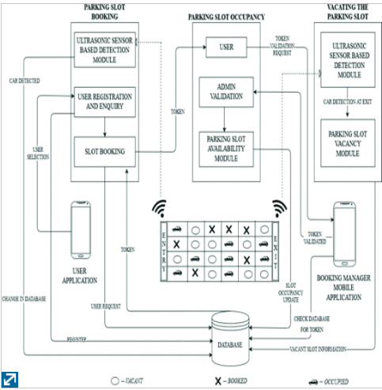

Figure 2 Proposed architecture of cloud-based parking slot detection

* **IoT based sensor enabled smart car parking for advanced driver assistance system:** the author(Mahendra et al., 2017) in his report develops a prototype to the parking assistance system to the driver where driver gets updated with the availability of the parking slot from mobile based application remotely with the approach to IoT’s. here for the identification of slots is identified by placing the IR sensor at each and every parking slots and when the vehicle is detected then in updates the value of slots to the database of the server which is monitored continuously by the cloud server and updated the information and sends to the requested driver and about the parking area and slots and also provides the facility of reserving of slot up to a period of time.

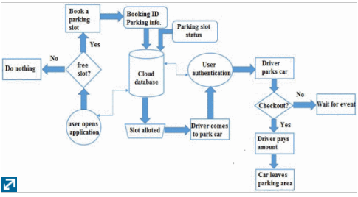

Figure 3 flow chart of mobile based application

The workflow process is explained through this flowchart all the above-mentioned project work but here need more to explain about full city management of parking areas and this report is confined to a smaller and one parking area. The author explains his report with the integration of all the sensor components which is controlled by embedded board and updates the information to the drives as per the selected option in the mobile based parking application. Here author (Mahendra et al., 2017) just explains the working prototype with three slots but it would be worthy enough if explains the in-city parking management.

1. **METHODOLOGY**

There are two phases considered for the development of the project to establishment the connection between the drivers and all the parking management system servers with maintaining the all activity of data at each end points by maintaining the database. There are two level of database management required to provides the information related to vehicle activity related to the accessing the slot to park and monitoring all the slots with continuous integration and updating the fields. So, the two levels where the data are maintained is one the database at local sever level where there relies the information to the number of vacant, occupied, booked slots and detail log of information of each vehicle which accessed the services by that parking area. The second level database at the cloud server which can also considered as central repository where it continuously monitors all the parking slots at each parking area and continuously updates its field whenever the changes occurs to provide the real- time information to the driver about the status of the nearby slots of the parking stations to access the reliable services by selecting one of the parking providers by sending the request to cloud server CS and CS updates the driver desired services to that selected parking provider by the driver in the city by updating the information to the local server of that parking management system to make changes accordingly the request made by the driver and sends the confirmation of the request by driver

* 1. **PLAN OVERVIEW**

The plan overview is based on the three phases. They are

1. Developing the internal parking management system
2. Developing the user- friendly web application smart parking system at large area
3. Integrating and managing the both system with cloud server

* 1. **BLOCK DIAGRAM**

In this section the block diagram for each phase is explained in following sub-sections which details the working mechanisms of each phase.

* + 1. **BLOCK DIAGRAM FOR THE INTERNAL PARKING MANAGEMENT SYSTEM**

Here the block diagram if the internal parking area for two slots is shown which is connected to the local server wirelessly using the WIFI module.

SERVO MOTOR

PROXIMITY SENSOR at slot1

LCD SCREEN

ARDUINO UNO

PROXIMITY SENSOR at slot 2

SERVO MOTOR

Wi-Fi MODULE

SERVO MOTOR

Wireless connection to the database of the local server

Local server

BLOCK DIAGRAM

* + 1. **COMPONENTS REQUIRED**

There are few basic components requires for the setup installation of the whole system in the inside of the parking management system.

ARDUINO UNO BOARD: It is a controller board which is operated with an ATmega328 microcontroller. It is like a miniature PC like controller with memory units, system programmable peripheral device and ports used to connect the sensors, where the sensors are operated according to the Arduino programming IDE i.e., integrated development Environment.

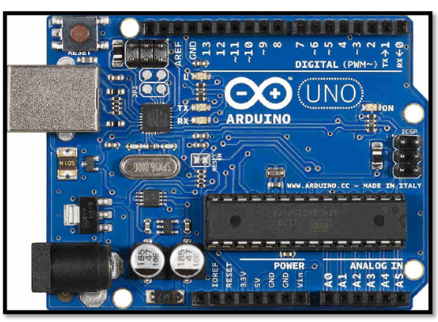

Figure 4 ARDUINO UNO

LCD DISPLAY: In this project 16x2 LCD module is used. It requires to display the information of the slots to the driver before entering into the parking area. It displays the total number of occupied slots To, total number of available slots Ta, total number of booked slots Tb and total number of slots in that parking area.

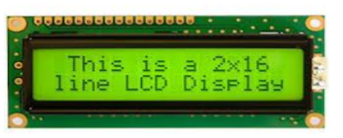

Figure 5 LCD MODULE 16X2

PROXIMITY SENSORS: The proximity sensor of version sharp GP2D12 sensor is used and is controlled by Arduino UNO. Here it used to detect the vehicles distance within its range of sensing and sends the results to the controller board for operation while entering and exit of the vehicle at allocated parking slot. This proximity sensor has range of 10 cm to 80 cm of working mechanism of sensing the in front object. It consists of two IR tubes of led where on transmit the IR rays and other receives the reflected IR rays. The duration of between two IR wave pulses considered for the calculation of the distance as (6787/(V-3) – 4) cm.

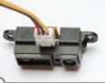

Figure 6 GP2D12

SERVO MOTOR: The railing is attached to the shaft of the servo motor whose position is controlled for 180 degrees. Servo motor is also a DC motor with internal mechanism and its shaft position is controlled by sending the pulse, though it is not powerful enough motor but for this project prototype is enough for the controlled operation of the gates.

This motor requires 5V to 6V of power to drive the motor. PWM signal is used to control the motor drive as it gives the logic level input to the determine the shaft position.

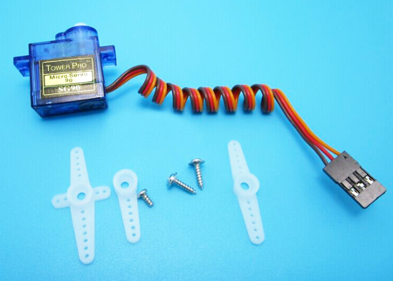

Figure 7 SERVO MOTOR

LED LIGHTS – Light Emitting Diode operates on the values obtained from the IR sensor and depending on these values the corresponding lights that is red, blue and green light will glow.

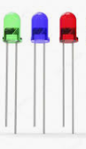

Figure RED, BLUE, GREEN LED LIGHTS

RED LED - indicates that the slot is occupied,

BLUE LED - indicates and alerts that the vehicle is going too close to wall,

GREEN LED - indicates that the parking slot is empty.

Wi-Fi MODULE: The ESP8266 provides the wireless connection between the existing network and as WEB Server and allows multiple connection to access its web page. This module  (Last Minute Engineers, 2018) works as Station mode and Access point mode and sometimes both. Using this module, we can control the system from web browser as when this module is configures and while browsing with the IP address then it sends a HTTP request to ESP8266 to handle this request thus can be operated through web browser.

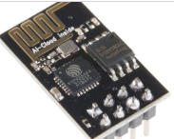

Figure ESP8266 NodeMCU

BUZZER – This electronic device used as alarm system. It is operated by the pulse signal as per the code-controlled operation of the Arduino board. It generates the pulse of as cautious signal of sound when a vehicle is approaching in wrong direction or while entering the reserved slot or about to collide the walls. In this project we are using buzzer in each parking slot to alert the driver of the vehicle to park the vehicle with cautious and alert for further danger such as colliding to the wall.

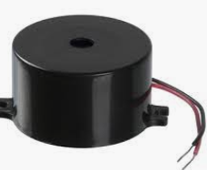

Figure BUZZER

* + 1. **WORKFLOW PROCESS OF PROPOSED PARKING SYSTEM**

The workflow process of the internal parking management system is described in this following flowchart.

No entry, all parking slots are full

Is slot available?

Green LED

Blue LED

Red LED

Is dist. < 10?

LCD Display connected with the Arduino update the information of slot availability

Enter parking area and check the and move towards green led slot

IR sensor GPD21 detects the vacant slot and distance of the vehicle

Gate operated by servo motor opens as the vehicle approaches near to the vacant slot.

Update to local server using Wi-Fi module

Updates the slots

No

Yes

Is dist. < 20?

No Yes

Flowchart WORKFLOW PROCESS

* + 1. **THE DESIGN OVERVIEW FOR THE PROTOTYPE OF AN INTERNAL PARKING MANAGEMENT SYSTEM**

The architectural design overview of a parking management system is shown, and it clearly displayed the wireless connectivity of the sensors in the individual parking slots to the local server database of the management of that parking area.

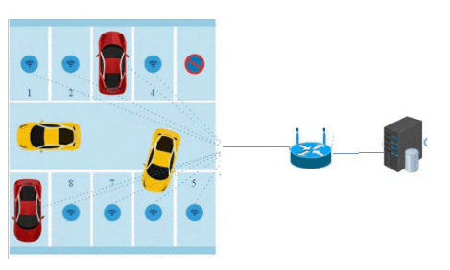



WIRELESS CONNECTIVITY

LOCAL SERVER DAATABASE

WIRELESS ROUTER

Controlled sensors component has per the block diagram

Figure OVERVIEW ARCHITECTRE DESIGN OF PHASE 1 INTERNAL PARKING MANAGEMENT SYSTEM

When the vehicle is entered in the parking slot then the locating of the vacant slot can easily be detected by the color of the led and each case of the detection method mentioned above can be understandable by the above figure 12. All these sensors are connected wirelessly by using WIFI module (circuitdigest.com, n.d.) to the sensor board which acts at as station and the other one connected to the local server is the access point AP to which number of Wi Fi modules nodes are connected.

* + 1. **THE BLOCK DIAGRAM OF INTEGRATING DIFFERENT PARKING MANGEMENT PROVIDERS TO DRIVER**

P1

DRIVER

P2

Parking providers

CLOUD SERVER

Pn

BLOCK DIAGRAM describing the aporach of project

The connection between at both the end points for the data transfer and receiving. The driver who is connected to the cloud by using the internet provided by the mobile operators. For parking slot, the drives connect with the cloud and sends the request.

In larger area there are many numbers of parking slots providers and sometimes in is unaware of these providers to the driver.

All the parking management providers local servers are connected wireless to the central server which is continuously monitors all these parking slots and updates its database with as change triggers to provide the accurate and reliable real- time information to the drivers of the vehicle.

* + 1. **WORKFLOW ANALYSIS OF PROJECT’S PROPOSED METHODOLOGY**
* Driver sends the request via mobile based application.
* Internet plays a major role in the operation of the all the procedure.
* The requested option made by the driver is sent to the cloud server.
* The driver is connected through the mobile network provider.
* The cloud server gets the location of the drives through the enable GPS and provides the nearest station parking providers details with the details of the slot.
* The cloud continuously monitors all the parking providers in the city and all the parking providers need to connect with the main server as it provides the platform for the parking providers to utilize their parking slots by the needed drivers.
* The user then selects the relevant parking provider slots by considering the information from the application like distance, time, price and updates the confirmation of the selecting slot for booking or just can be used to navigate to the location of the nearest parking provider.
* The cloud server then updates the request and reserve the slot as per requested and updates the information to the parking providers for the confirmation in case of any complications.
* After the confirmation request by the parking provider the confirmation message and mail is sent to the driver with parking provider address, direction and parking slot.
  + 1. **THE ARCHITECTURAL DESIGN OVERVIEW OF THE PROJECT**

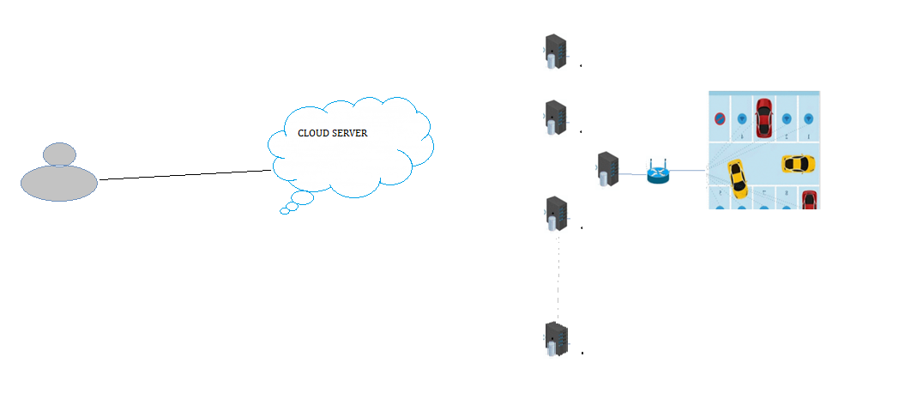

BLOCK DIAGRAM overview architectural design of project

1. **IMPLEMENTATION OF THE PROJECT**

The sensors, lights, buzzers and geared motors are to be arrange at each parking slot which is controlled by controller and the local server database for the management of the equipment at each slots are to be implemented at a parking provider which is the hardware implementation and when the local server connects to the central server it requires which is connected through the implementation of the programming for the reliable connection between the user and parking provides through cloud server through implementing a web based application which requires the software implementation of the proposed work.

* 1. **Hardware implementation**

The implemented hardware circuit design is shown below as the working prototype model which is present at each slot.

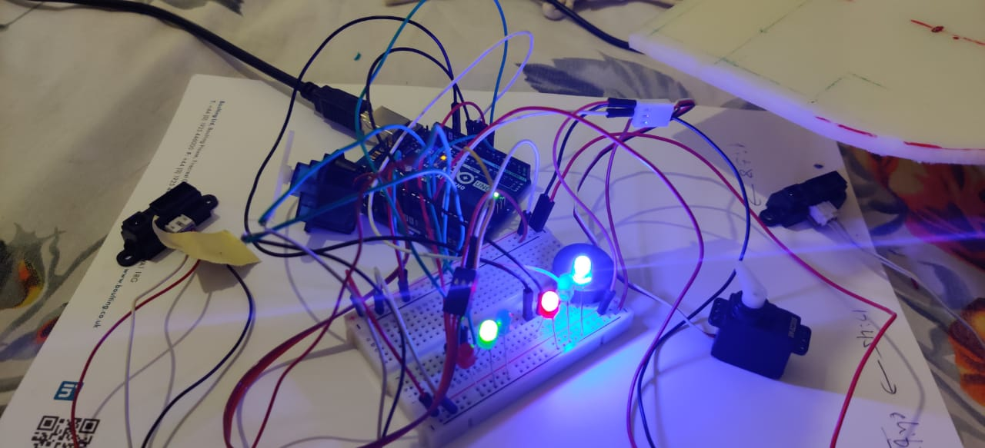

Object

Figure Implemented internal parking management system

IR2 sensor supposed to at slot2 detects an object

IR1 sensor considered to be at slot 1 detects no object within its range

**­­­Description:**

The above figure shows the prototype of the implemented internal parking management system and it is clearly displayed the working module. That two IR sensors are supposed to be placed in each parking slot used for the detection of the vehicle. There are two cases observed at one of the IR sensor a PVC board(assumed as vehicle) is placed the sensor automatically detected and accordingly to the distance the LED light are operated as the distance between the sensor and board is very less the RED LED for the detection of the board and the BLUE LED as detect the alarming indication to the driver when it is approach too close the wall. Another sensor doesn’t detect any object in front of it so GREEN LED operated as indication for the vacant slot. The output of these sensors in terms od distance detection is displayed below

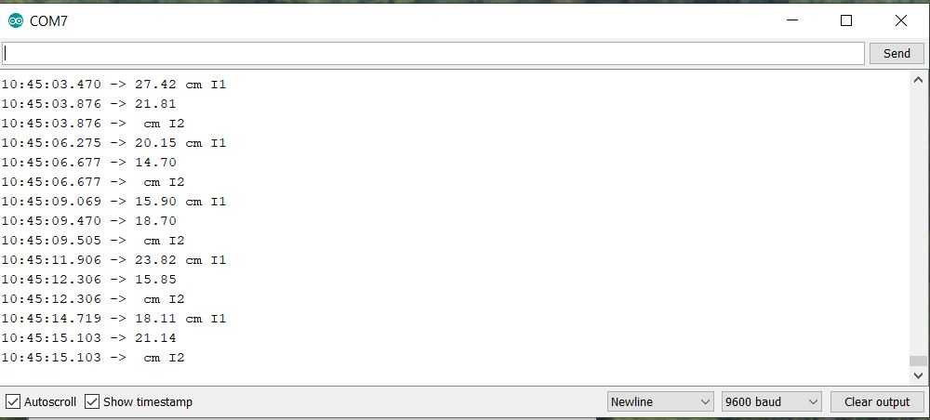

Figure output of IR SENSORS

1. **SOFTWARE IMPLEMENTATION**

The software implementation of this Smart Parking system is developed by integrating the different phases which are discussing in the plan over view by coding each and every component and all this coding are described below and the different coding parts algorithm which are involved in this project as follows.

1. Algorithm for the output at LCD display and serial monitor
2. Algorithm for implement code for sharp IR sensor
3. Code logic for servo motor
4. Code logic for WIFI module
5. Code to create establish the connection for web server
6. Web styling of HTTP page
7. Development of the mobile application app for the drivers
   1. **ALGORITHM FOR THE OUTPUT AT LCD DISPLAY AND SERIAL MONITOR.**

Let,

Vacant slots, Tv = X

Occupied slots, To = Y

Booked slots, Tb =Z

Total number of slots, Ta = X+Y+Z

Vacant slot is determined with color Green Led, To is determined with red LED and booked Slots is determined with Yellow LED

These LED lights are controlled with the programmable logic 1 and 0 as high and low depends on the IR sensor value.

Prototype model is made for two slots the program logic code is explained by following algorithm in terms of flow chart.

Is R1=high,

Is R2= high

R2

no yes

Output

R1=1 and R2=1

Output

R1=0 and R2=0

Output

G1=1 and G2=1

Is G1=high, G2=high

no yes

Output

G1=0 and G2=0

Is Z1 is high

Slot is booked

Z=Z+1, with initial Z=0

Slot is vacant

no yes

X= G1+G2

Y=R1+R2

Display x= availability slots, y= occupied slots and z= booked slots

Display total slots = X+Y+Z

Flowchart led operation

* 1. **ALGORITHM CODE FOR SHARP IR SENSOR GP2D12**

void loop ()

{

IR1 = analogRead (IR input value); // reads the value of the IR sensor

distance = (6787.0/ (Ir1val - 3.0)) -4.0;

Serial.print(Distance); // DISPLAYS OUTPUT//

**}**

* 1. **CODE LOGIC FOR SERVO MOTOR**

#include <Servo.h>

int servoPin1 = A2;

void setup()

{

Serial.begin(9600);

Servo1.attach(servoPin1);

}

void loop()

{

if ( fltIrc1 > 30 )

{

digitalWrite(LED1, LOW);

digitalWrite(LED2, HIGH);

digitalWrite(LED6, LOW);

lcd.print(" slot1 no ");

Servo1.write(90);

Servo1.write(0);

delay(1000);

}

* 1. **CODE LOGIC FOR Wi Fi MODULE TO CREATE AND ESTABLISH CONNECTION TO THE SERVER AND WEBSITE**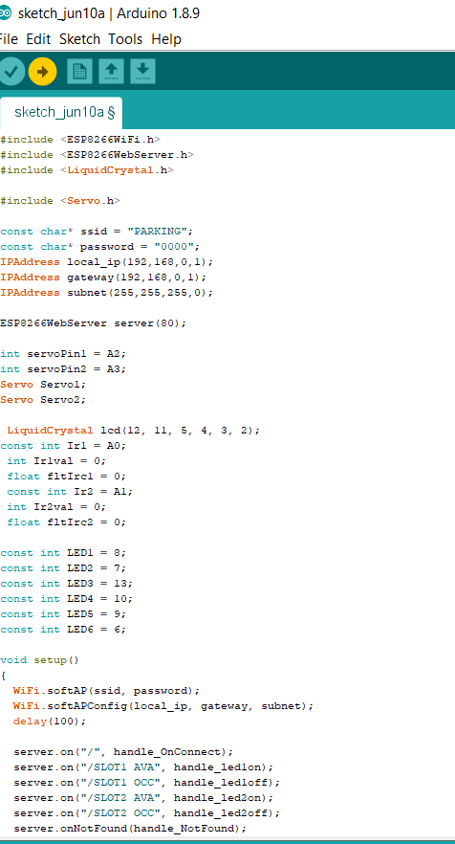

Specified Urls for the state of change of activity done on the status of slots

Configured HTTP server before running and output can be seen in serial monitor

Set the Wi-Fi establishment for soft AP by initializing all these parameters

Here the ESP8266 are established in AP mode and create the Wi-Fi network by configuring the SSID, PSW, IP address, IP subnet mask and gateway

Figure wifi code part1

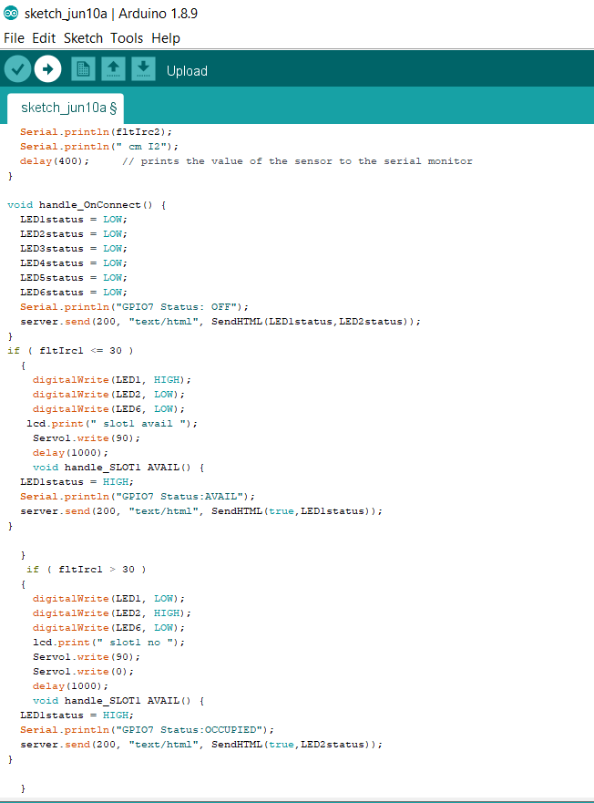

HTTP incoming change request

When server receives HTTP request it will trigger handle_onconnect ()

Figure code part 2

Web page styling done by implementing this code which includes the creating of heading, buttons as the state to make the decision by selecting the option.

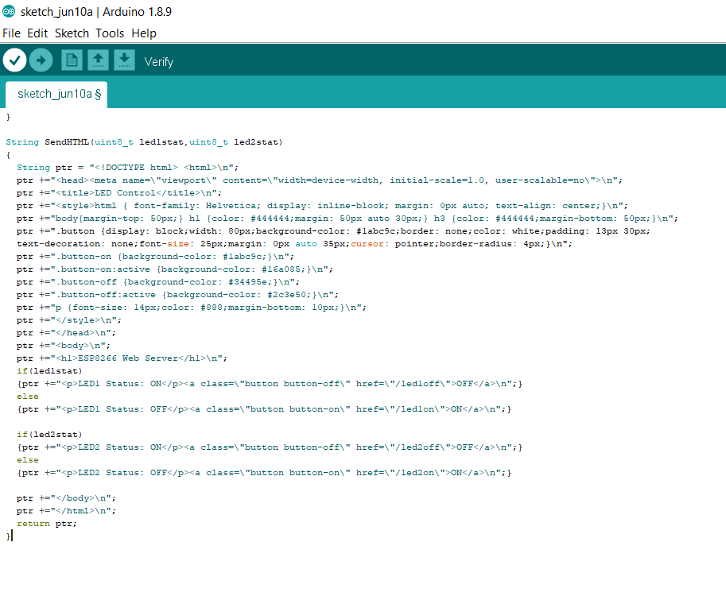

Figure web code

* 1. **The MOBILE APP OR ANDROID APP FOR THE DRIVERS**

The Android App in this app created by using the MIT App Invertor which is an free and open source tool to create the web browser program, interface with the graphic and convertor to mobile application from web browser to provide access to the mobile users.

The can made request by selecting the desired option provided in the app. As all the features are not able to add in this app while reporting this project due to time consumption but it can easily modify and can add further features to it.

At present the basic possible option is provided to use and as the model prototype of this project the images of this is shown below.

The login page: All the users have to register first while accessing this service to establish the record of each users or drivers in the main database that is cloud server for future modification, quality and testing and upgradation of the application by ensuring the all the safety and security regulations to the driver.

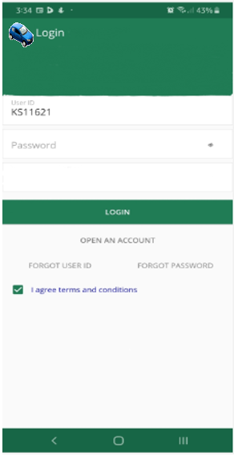

Figure login page

MENU SCREEN

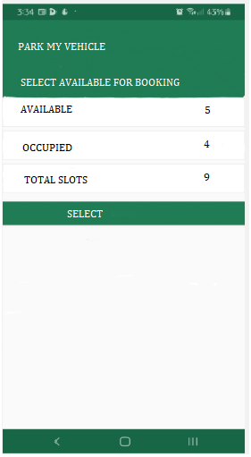

BOOKING MENU

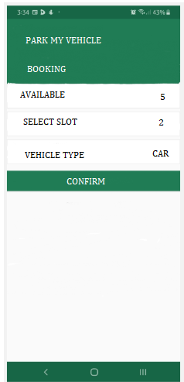

Thus, the driver can book the slots and confirmation mail is sent to the driver and same is reflected to the selected parking provider.

1. **CONCLUSION:**

This project report focus on simplification approach for simple living with the proper use of technology solves the consequences of the improper management of the parking of vehicles.

This paper tries to finds the best possible approach for efficient parking management system based on using wireless sensor node and subsequently updates the information in the respective servers provided at the parking providers and all these local servers are managed by the central cloud server which plays an platform where all the drives and parking providers can interact with each other which reduces the problem faced by the drivers in searching for the parking slots, traffic congestion, wasted time and efficient management for the providers as it fulfill the supply demand gap with the reduced human interference and manpower at the parking lots.

1. **FUTURE WORK**

The project can be enhanced by adding more features such as

1. Graphical interface to locate the location in map.
2. Direction assistance methods to reach the location of parking slots.
3. Providing the mobile app payment methods.
4. Adding easy user- friendly development of the mobile app to the drivers.
5. **REFERENCES**

Desk, S.D. (2020). *Bangalore has worst traffic in the world; Mumbai, Pune ranked in top 5, says report- Sentinelassam*. [online] www.sentinelassam.com. Available at: https://www.sentinelassam.com/national-news/bangalore-has-worst-traffic-in-the-world-mumbai-pune-ranked-in-top-5-says-report/?infinitescroll=1

Jul 20, B.M.B.| U., 2019 and Ist, 06:00 (n.d.). *Park in designated spot only, Sophia parents told*. [online] Bangalore Mirror. Available at: https://bangaloremirror.indiatimes.com/bangalore/civic/park-in-designated-spot-only-sophia-parents-told/articleshow/70300755.cms [Accessed 7 Jun. 2020].

‌ Verdict Traffic. (2017). *RTA Dubai launches Smart Parking Project*. [online] Available at: https://www.roadtraffic-technology.com/news/rta-dubai-launches-smart-parking-project/ [Accessed 7 Jun. 2020].

Tyagi, C. (2018). How Get My Parking is resolving parking issues with a mobile app. *The Economic Times*. [online] 8 Jan. Available at: https://economictimes.indiatimes.com/small-biz/startups/features/how-get-my-parking-is-resolving-parking-issues-with-a-mobile-app/articleshow/62410803.cms?from=mdr [Accessed 7 Jun. 2020].

Last Minute Engineers. (2018). *In-depth: Create A Simple ESP8266 NodeMCU Web Server In Arduino IDE*. [online] Available at: https://lastminuteengineers.com/creating-esp8266-web-server-arduino-ide/ [Accessed 10 Jun. 2020].

Mahendra, B.M., Sonoli, S., Bhat, N., Raju and Raghu, T. (2017). *IoT based sensor enabled smart car parking for advanced driver assistance system*. [online] IEEE Xplore. Available at: https://ieeexplore.ieee.org/document/8256988 [Accessed 10 Jun. 2020].

U., V., Sharma, S., Katiyar, B. and Prashanth, Y. (2018). *A Wireless Sensor Node Based Efficient Parking Slot Availability Detection System For Smart Cities*. [online] IEEE Xplore. Available at: https://ieeexplore.ieee.org/document/8443892 [Accessed 10 Jun. 2020].

ResearchGate. (n.d.). *(PDF) IoT Based Smart Parking System*. [online] Available at: https://www.researchgate.net/publication/329686583_IoT_Based_Smart_Parking_System [Accessed 10 Jun. 2020].